**Skill/Job recommender application**

CHANDRA SRUJAN

HARI PRASATH.S

GUBBA VENKATA SUCHENDRA LAKSHMI PATHI

GORELLA MOHAN SIVA DURGA PRASAD

**R.M.D Engineering college**

**Abstract:**

There has been a sudden boom in the technical industry and an increase in the number of good startups. Keeping track of various appropriate job openings in top industry names has become increasingly troublesome. This leads to deadlines and hence important opportunities being missed. Through this research paper, the aim is to automate this process to eliminate this problem. The intention is to aggregate and recommend appropriate jobs to job seekers, especially in the engineering domain.

The entire process of accessing numerous company websites hoping to find a relevant job opening listed on their career portals is simplified.

**Architecture diagram**

**:**

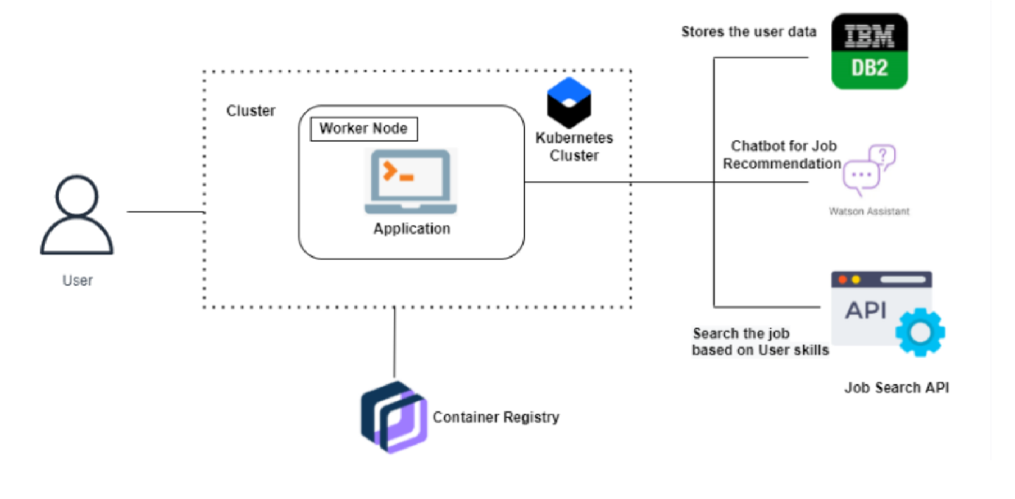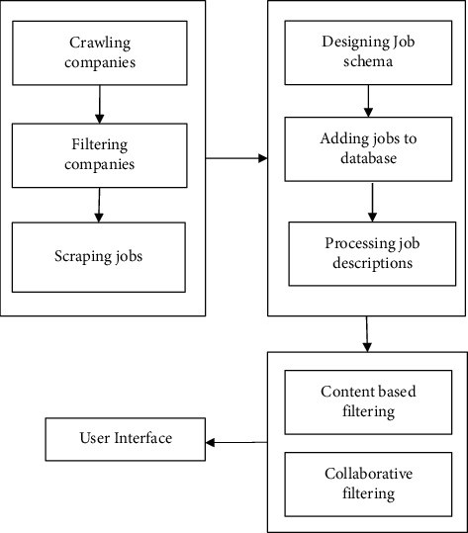

**Modules:**

**Data Collection:**

The database used for this system was created using refined and customized data collection techniques and methods. This technique helps distinguish the database from the already existing commercially available job databases.

**Recommendation System:**

Recommendation systems proposed in are mechanisms for information filtering that smartly identify and segregate information. They create smaller chunks out of large amounts of dynamically generated information. A recommendation system has the ability to predict whether a specific user will prefer an article or not based on their profile and its past information

**Content-based filtering :**

1.Profile-Description Matching

2. Keyword-Based Searching